

C
P
ROJECT
SUBMITTED
BY
:
Deepak Singh

Batch:
46
SAP
ID:
590025971
UNIVERSITY:
School
of
Computer
Science,
UPES
Dehradun
SUBMITTED
TO
:
Dr. Dolly Das



STUDENT REPORT CARD
SYSTEM

ABSTRACT
The Student Report Card Management System is a C-based console application designed to efficiently manage academic information for multiple students. This project demonstrates the practical use of key C programming concepts such as structures, pointers, arrays, loops, conditional statements, functions, dynamic memory allocation, sorting techniques, and file handling.
The system allows the user to input student details, calculate total marks, average, grade, and pass/fail status automatically. It supports multiple entries at once and arranges students in descending order based on their total marks to clearly identify academic performance levels. Additional features such as searching for a student by roll number, displaying the class topper, and saving the complete report to a file enhance the usability and functionality of the program.

CODE

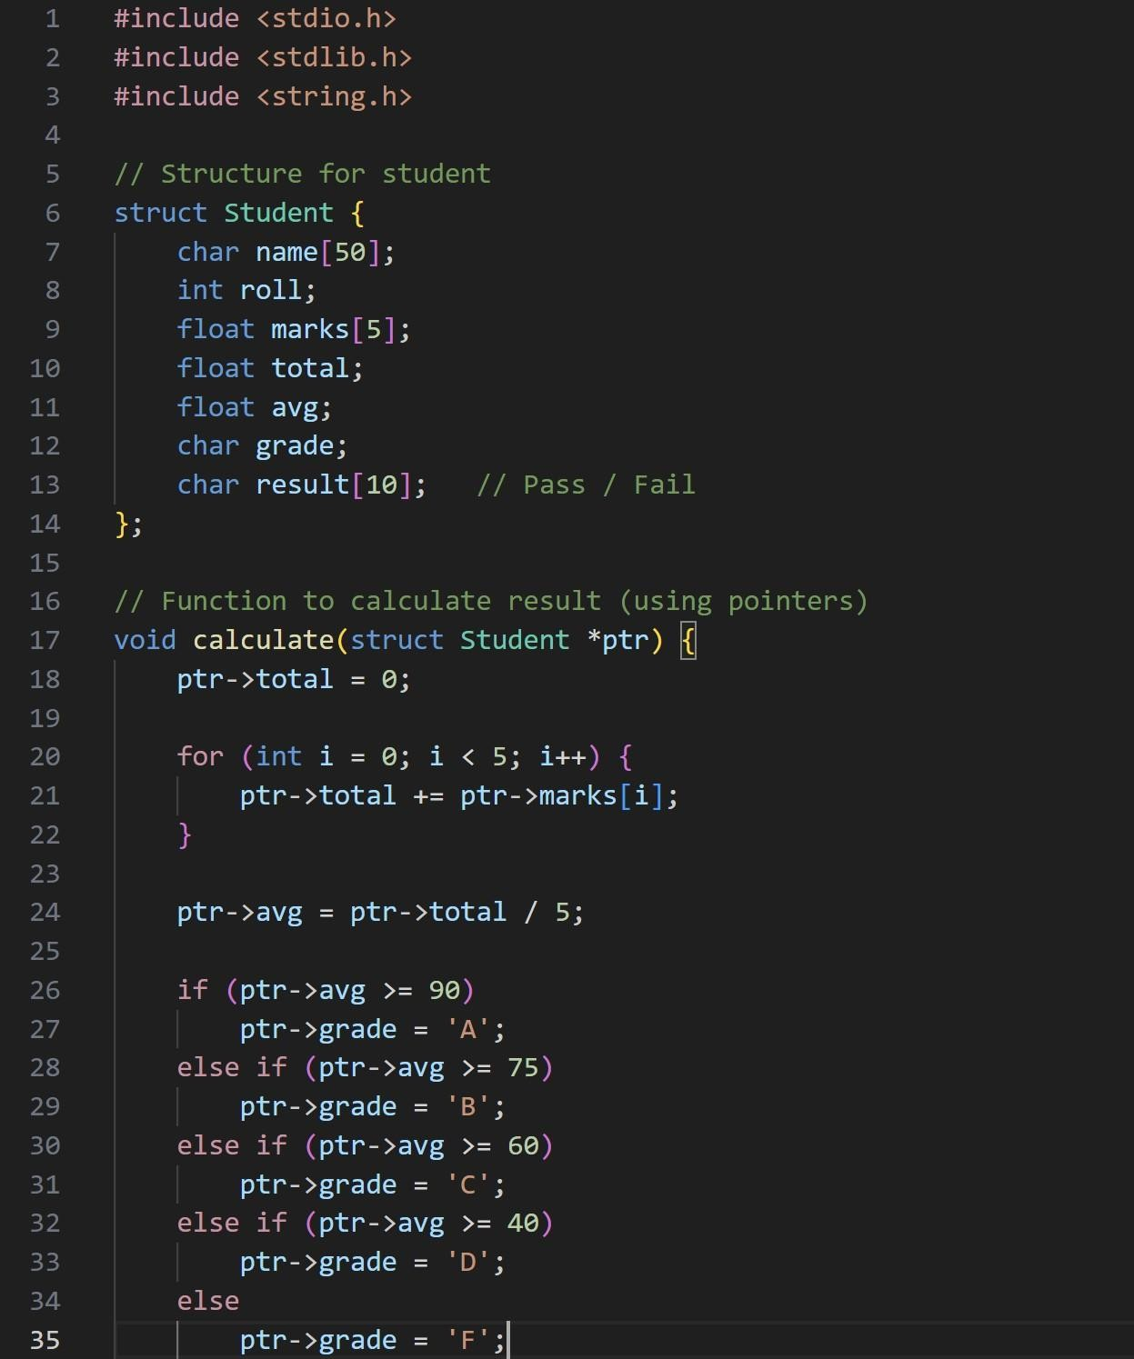
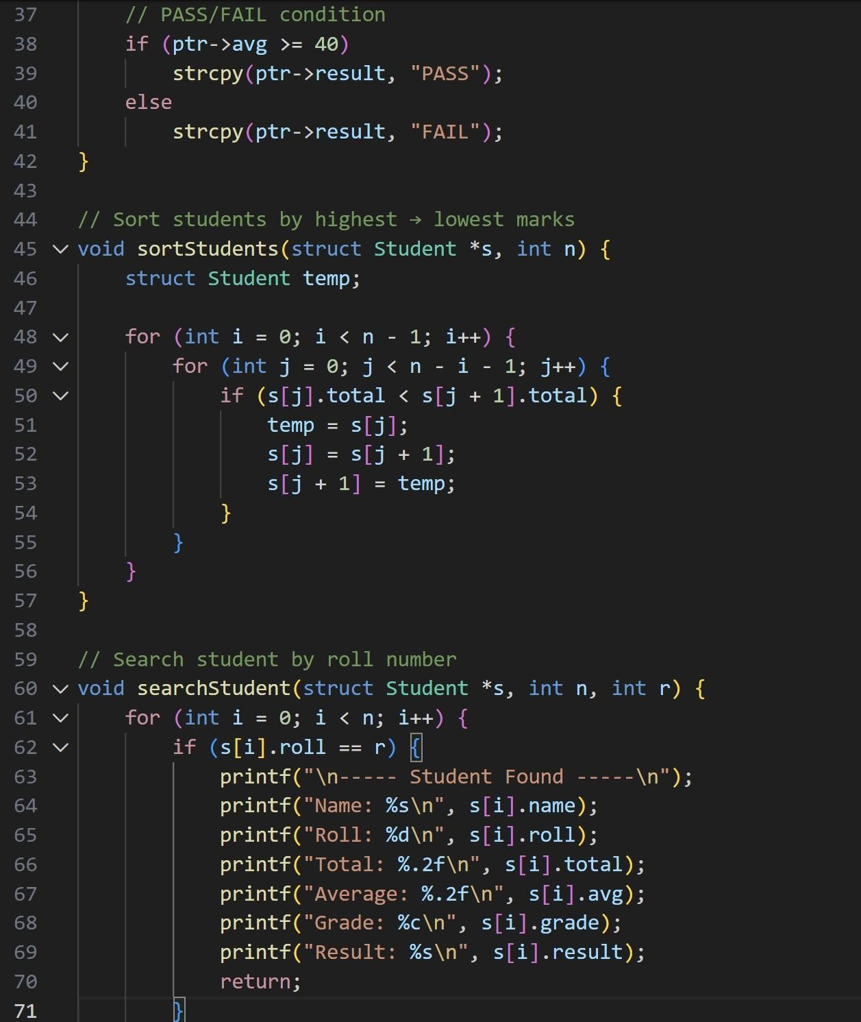
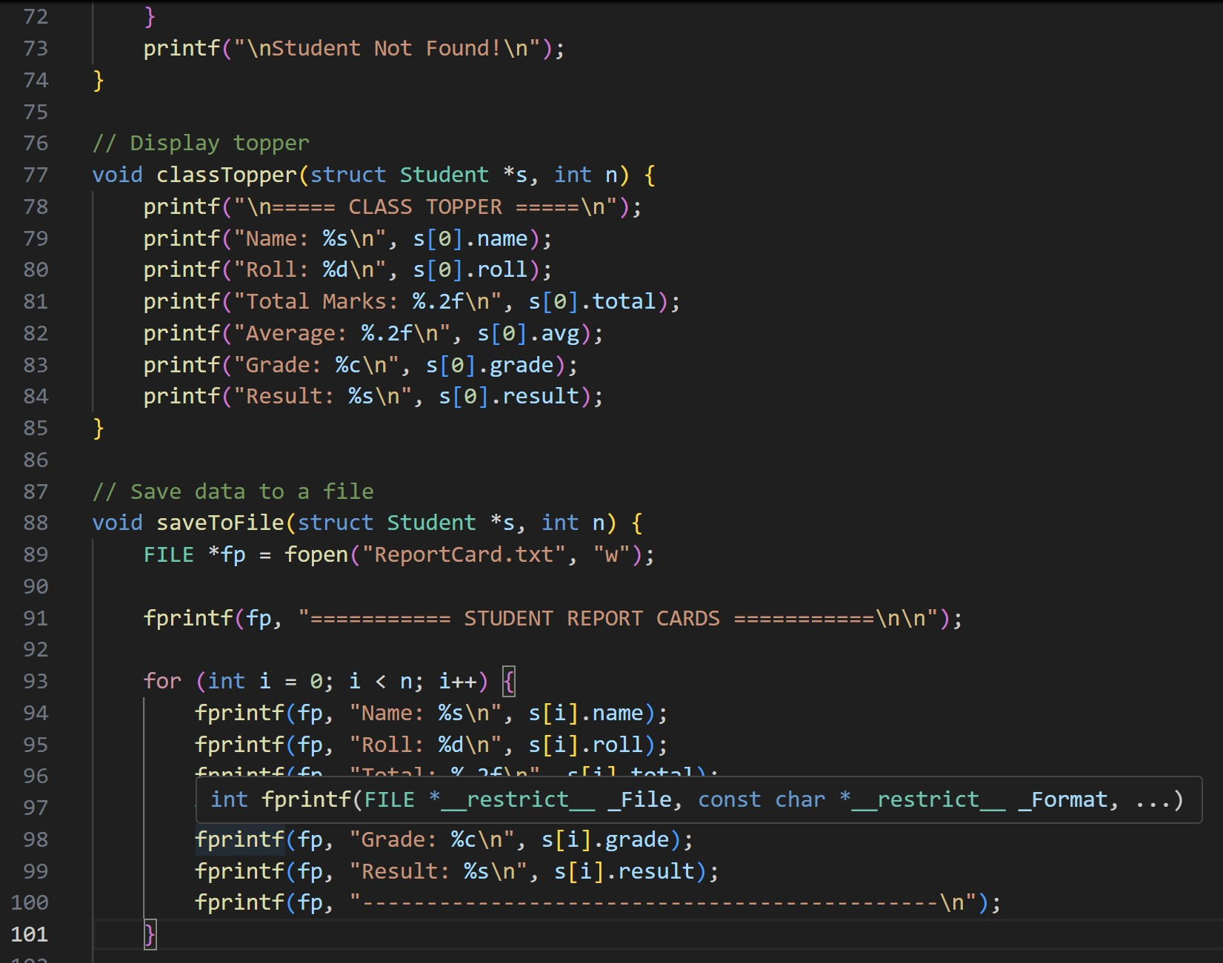
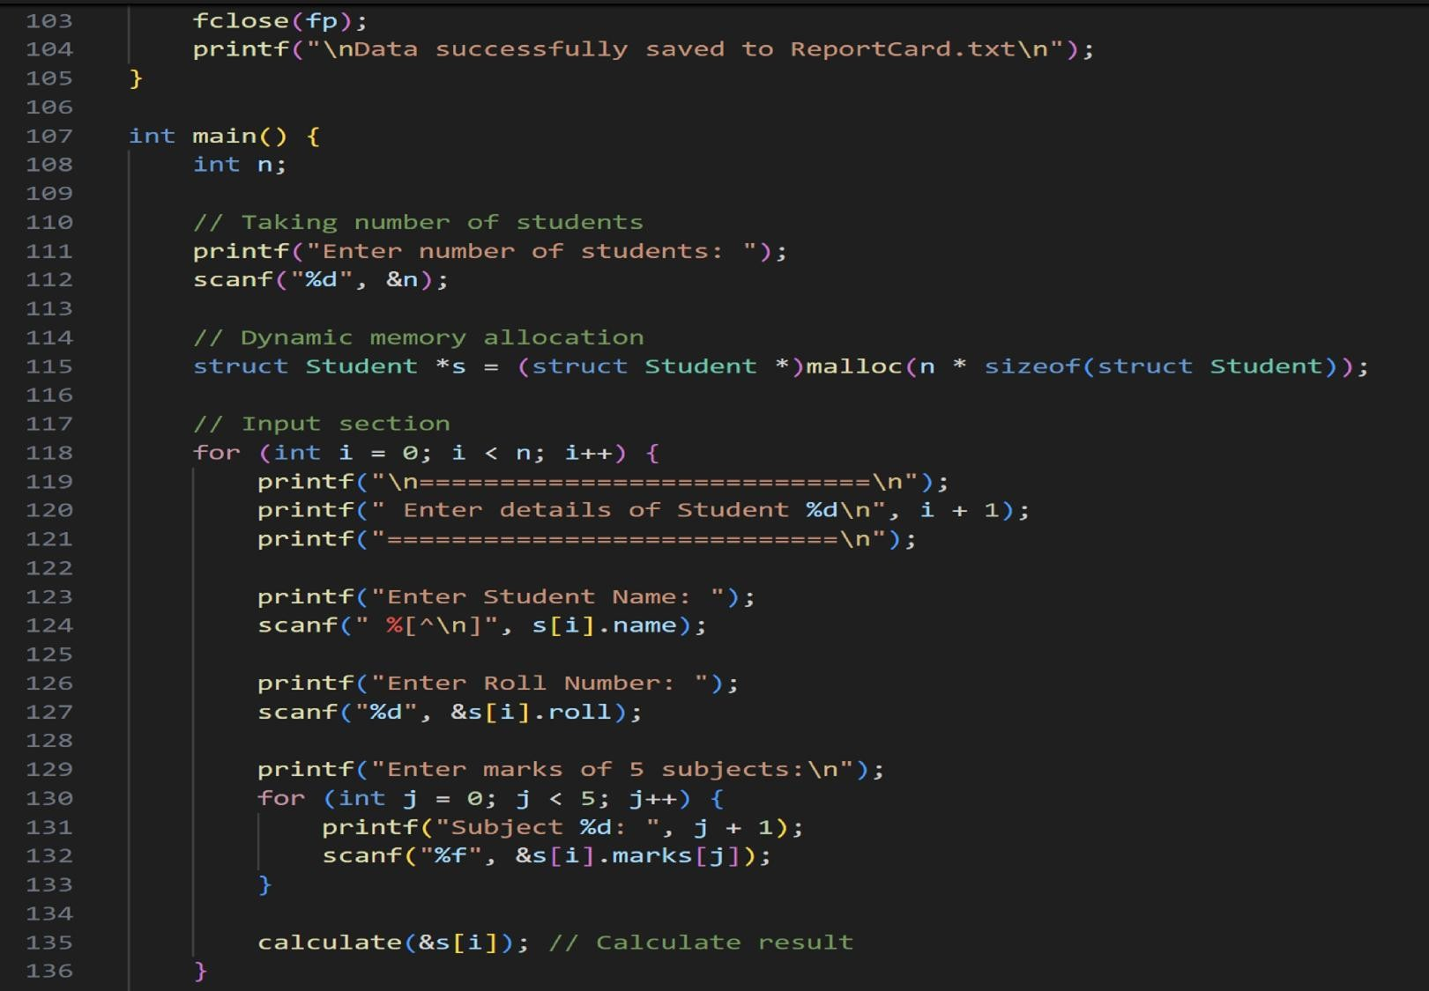
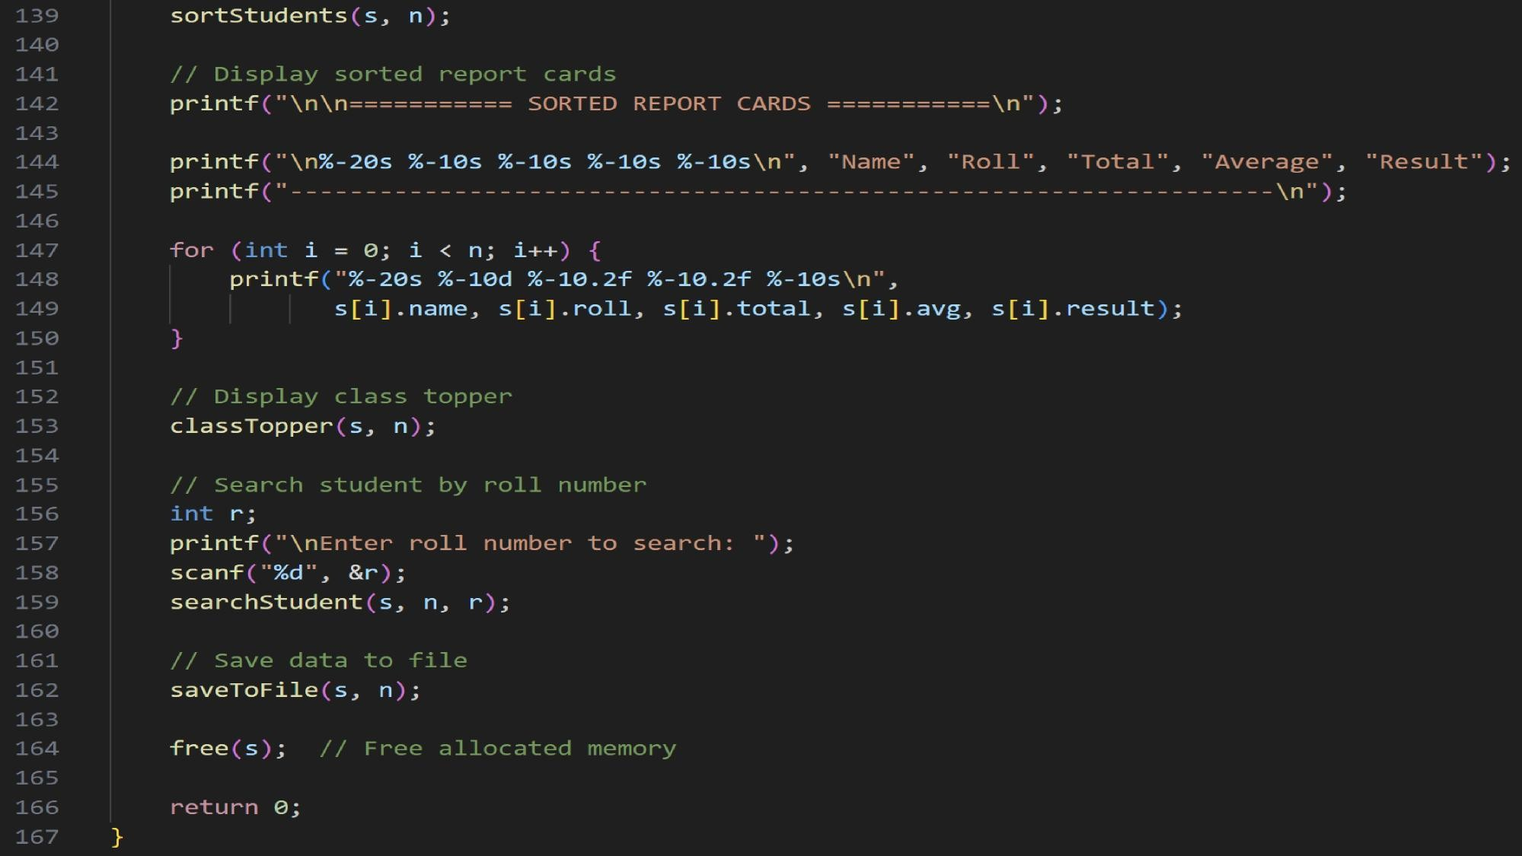

EXPLANATION OF CODE
1. Header Files
#include <stdio.h>
#include <stdlib.h>
#include <string.h>
•stdio.h → used for input/output functions like printf, scanf, fopen.
•stdlib.h → allows dynamic memory allocation using malloc() and free().
•string.h → used for string functions like strcpy(). 2. Structure Definition
struct Student { char name[50]; int roll; float marks[5]; float total; float avg; char grade; char result[10]; }; The structure groups all related student data:
•name → stores student’s full name
•roll → roll number
•marks[5] → marks of 5 subjects
•total → sum of all marks
•avg → average marks
•grade → letter grade (A–F)
•result → “PASS” or “FAIL”
- calculate() Function
void calculate(struct Student *ptr)
•Takes a pointer to a student structure.
•Calculates total marks by looping through the marks array.
•Finds average by dividing total by 5.
•Determines grade based on average.
•Assigns PASS/FAIL depending on whether average ≥ 40.
This uses a pointer so changes directly modify the original structure.
- Sorting Function
void sortStudents(struct Student *s, int n)
•Sorts the entire student list in descending order of total marks.
•Uses the Bubble Sort technique. •Highest scorer becomes the first element. This is helpful for ranking students.
- Search Function
void searchStudent(struct Student *s, int n, int r)
•Searches through the array using a simple loop.
•Compares roll numbers.
•If found, prints detailed report of that student.
- Topper Functionvoid classTopper(struct Student *s, int n)
•Displays the first student in the sorted list.
•Since list is already sorted, the topper is at index 0.
- File Handlingvoid saveToFile(struct Student *s, int n) •Opens a file named ReportCard.txt in write mode.
•Saves every student’s report into the file.
•Closes file after writing.
This makes the data available even after the program ends.
- main() FunctionStep 1 — Ask number of students scanf("%d", &n);
Step 2 — Dynamic Memory Allocation struct Student *s = (struct Student
*)malloc(n * sizeof(struct Student));
•Allocates memory for n student records.
•Very efficient because memory is allocated at runtime. Step 3 — Input Student Data A loop runs n times: scanf(" %[^\n]", s[i].name); scanf("%d", &s[i].roll); Then, marks of 5 subjects are entered: scanf("%f", &s[i].marks[j]); Immediately after input: calculate(&s[i]); Step 4 — Sorting Students sortStudents(s, n);
Sorts the students from highest total marks to lowest. Step 5 — Displaying Result A table is printed: printf("%-20s %-10s %-10s %-10s %-10s\n", ... ); It shows:
•Name
•Roll
•Total
•Average
•Result
Step 6 — Class Topper
classTopper(s, n);
Displays topper details.
Step 7 — Search Function scanf("%d", &r); searchStudent(s, n, r); User searches by roll number. Step 8 — Save to File
saveToFile(s, n);
Stores everything in a text file. Step 9 — Free Memory
free(s);
Releases dynamically allocated memory.

TEST CASE (OUTPUT)
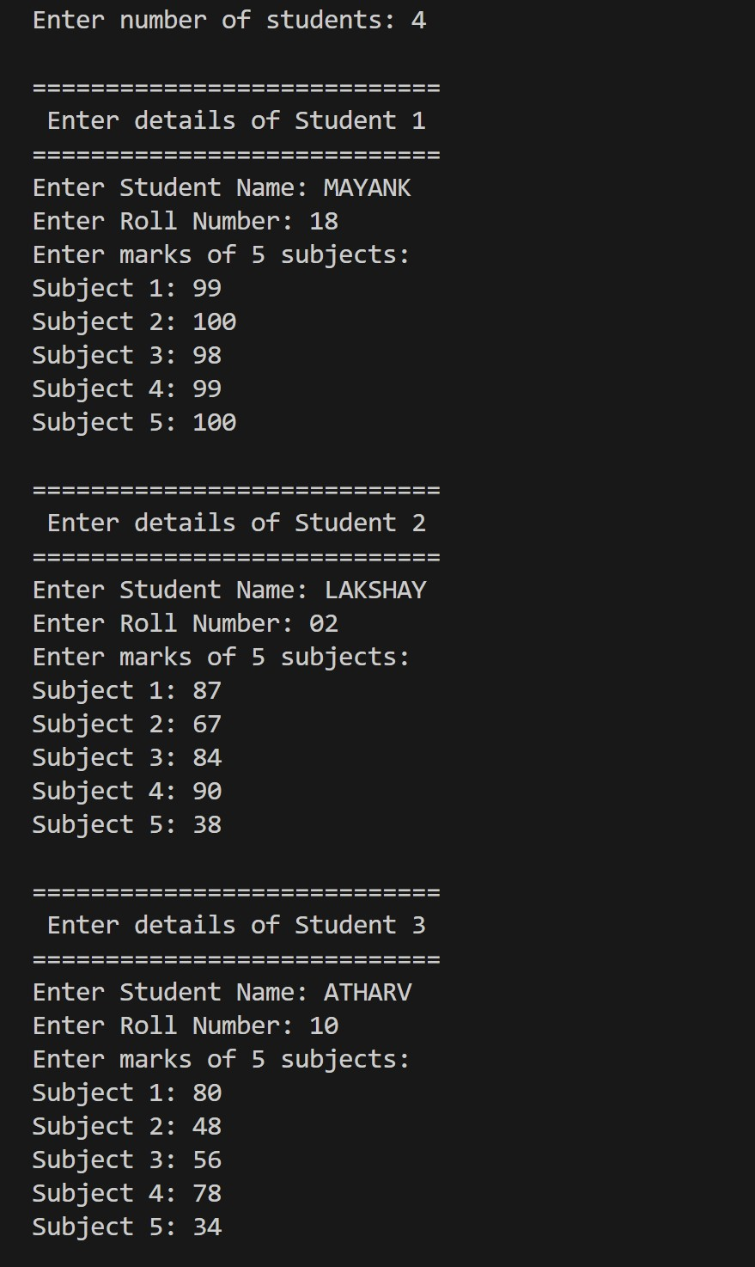

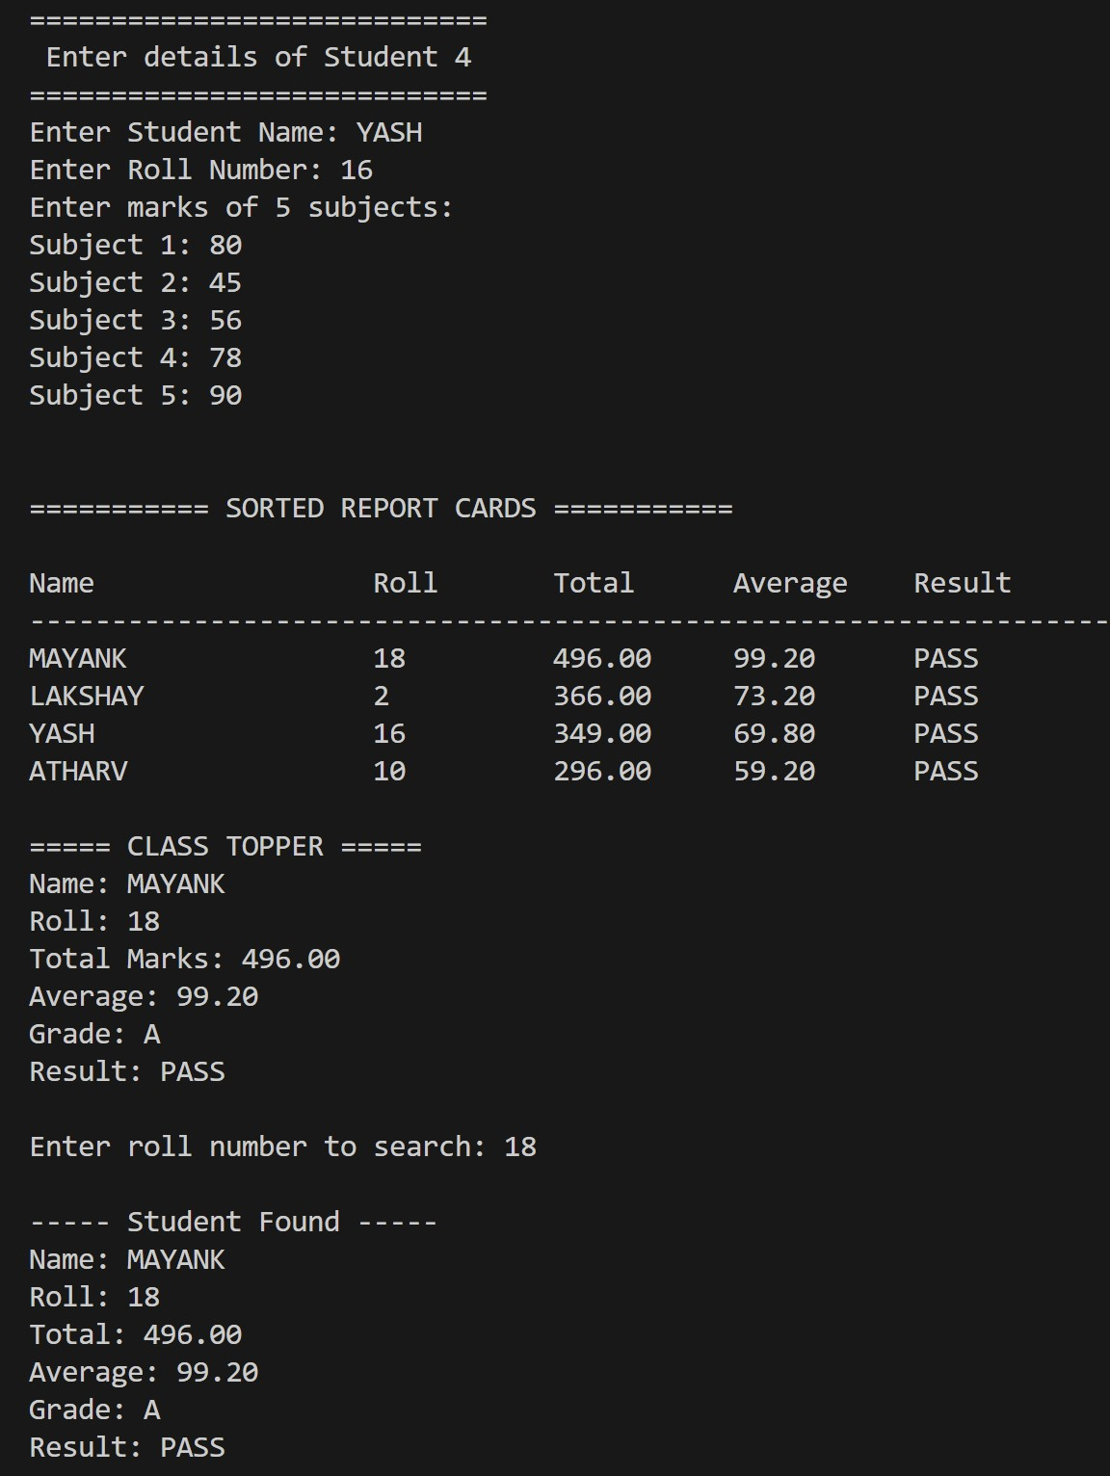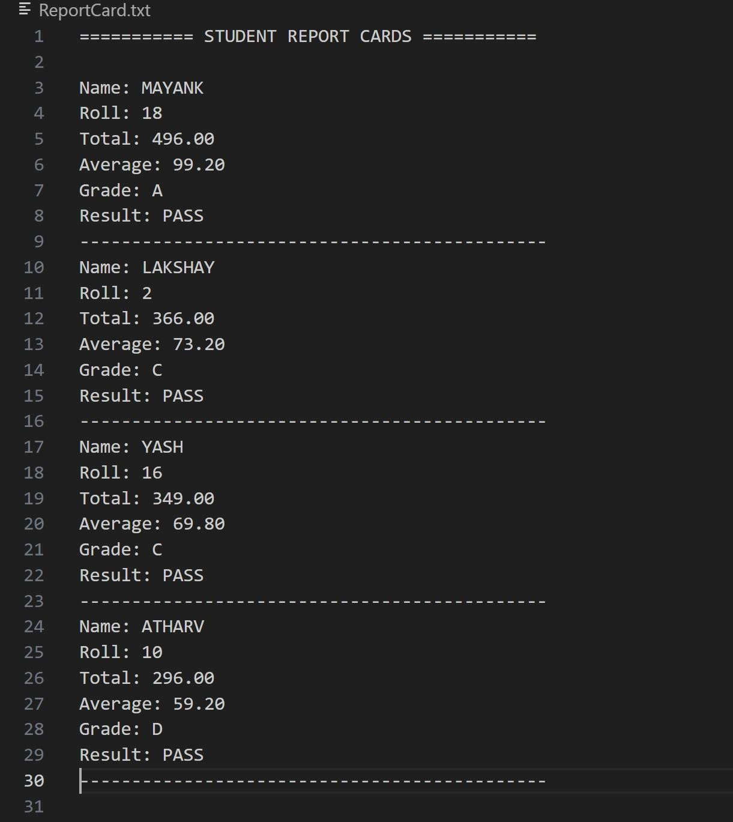
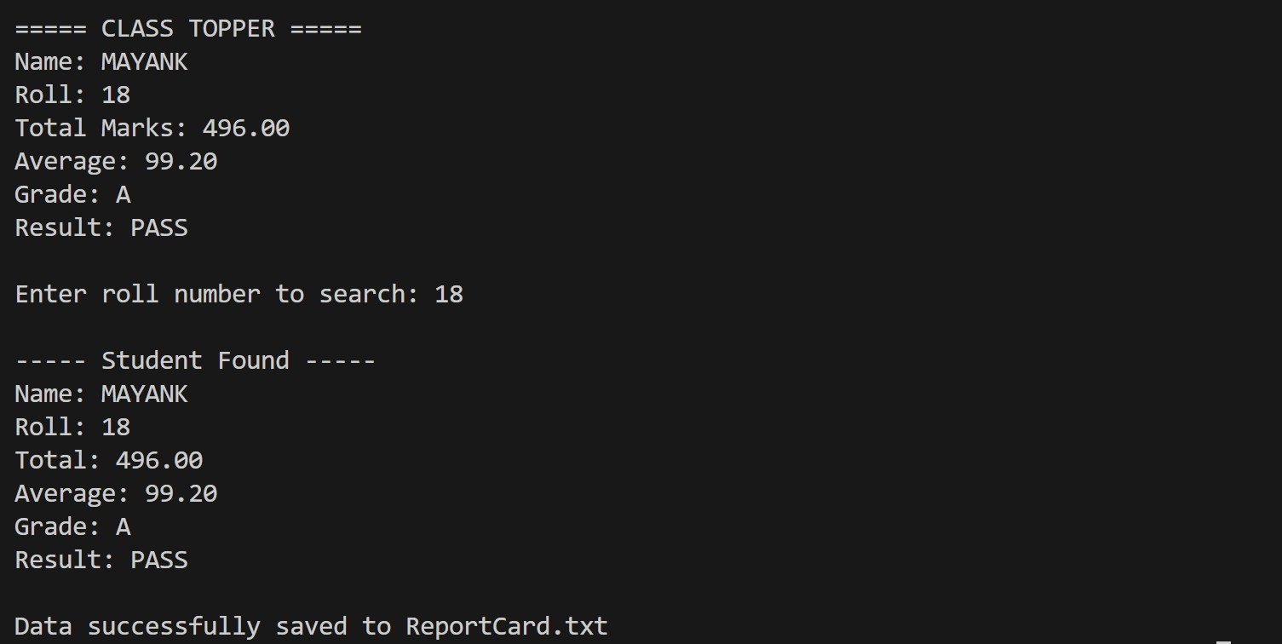

CODE
#include <stdio.h> // Structure for student\ struct Student {
char name[50];
int roll; float marks[5]; float total; float avg;
char grade;
};
// Function to calculate result (using pointers)void calculate(struct Student *ptr) { ptr->total = 0; for (int i = 0; i < 5; i++) {
ptr->total += ptr->marks[i];
}
ptr->avg = ptr->total / 5; if (ptr->avg >= 90) ptr->grade = 'A’;
else if (ptr->avg >= 75)

ptr->grade = 'B’;
else if (ptr->avg >= 60) ptr->grade = 'C’; else if (ptr->avg >= 40) ptr->grade = 'D'; else
ptr->grade = 'F’;
} int main() { struct Student s;
struct Student *p = &s; // pointer pointing to structure printf("Enter Student Name: "); scanf(" %[^\n]", p->name); printf("Enter Roll Number: "); scanf("%d", &p->roll); printf("Enter marks of 5 subjects:\n");
for (int i = 0; i < 5; i++) { printf("Subject %d: ", i + 1);
scanf("%f", &p->marks[i]);
}
calculate(p); // passing pointer to function printf("\n======= STUDENT REPORT CARD =======\n"); printf("Name: %s\n", p->name);
printf("Roll Number: %d\n", p->roll); printf("Total Marks: %.2f\n", p->total);\ printf("Average: %.2f\n", p->avg);
printf("Grade: %c\n", p->grade); printf("===================================\n");
return 0;
}



